**NAME- DEVANSHU SURANA**

**ELECTIVE ROLL NO-BT1-18**

**PANEL ROLL NO- PC-23**

**PRN-1032210755**

**PANEL-C**

Experiment 5

BT

**Problem Statement:**

Install Ganache blockchain test network and deploy solidity smart

**Aim:**

To install Ganache blockchain test network and deploy solidity smart

Theory:

Ganache:  
i)Ganache is a personal blockchain for rapid Ethereum and Filecoin distributed application development.

ii)You can use Ganache across the entire development cycle; enabling you to develop, deploy, and test your dApps in a safe and deterministic environment.

iii)Ganache comes in two flavors: a UI and CLI.

iv)Ganache UI is a desktop application supporting Ethereum and Filecoin technology.

v)It offers:

a.Zero-config Mainnet and testnet forking

b.Fork any Ethereum network without waiting to sync

c.Ethereum JSON-RPC support

d.Snapshot/revert state

e.Mine blocks instantly, on demand, or at an interval

Output:

i)Visit trufflesuite.com/ganache/ and download “Ganache for Windows”.

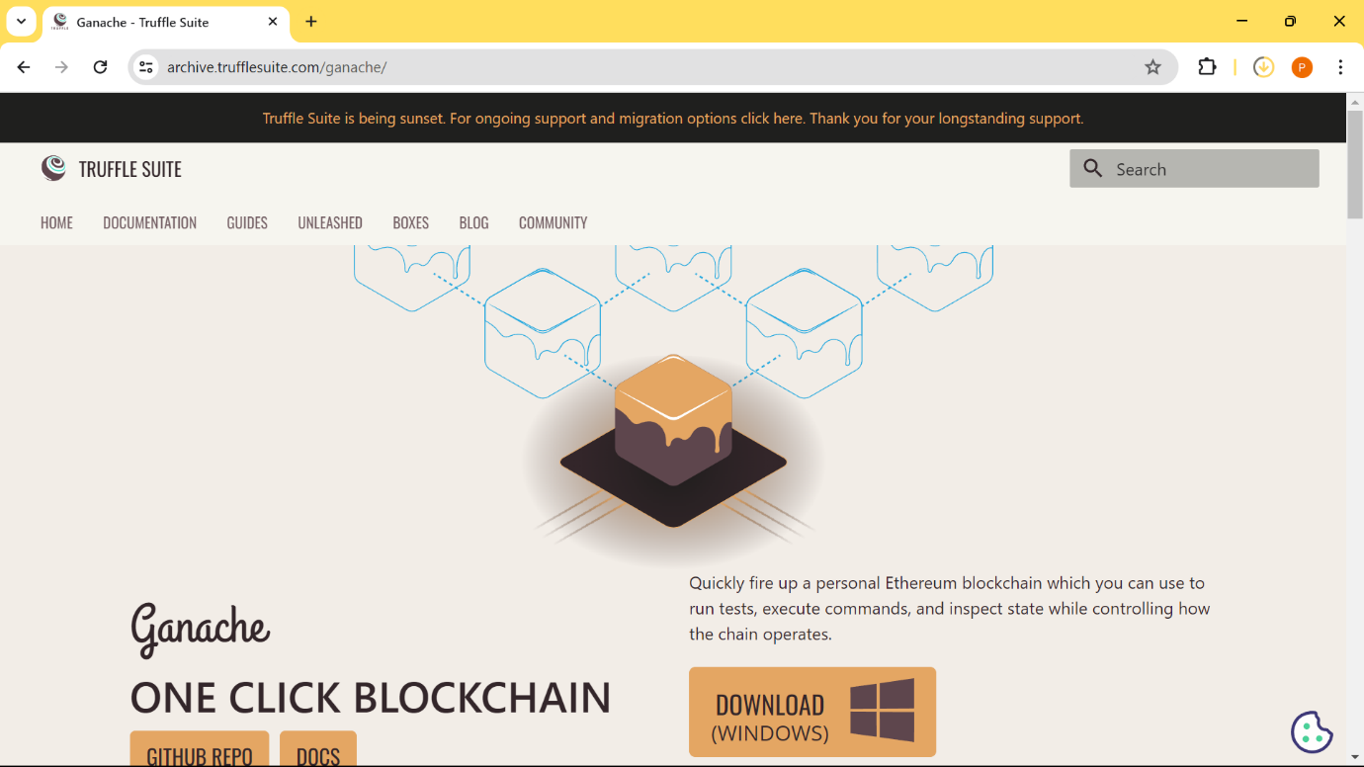

ii)Install Ganache

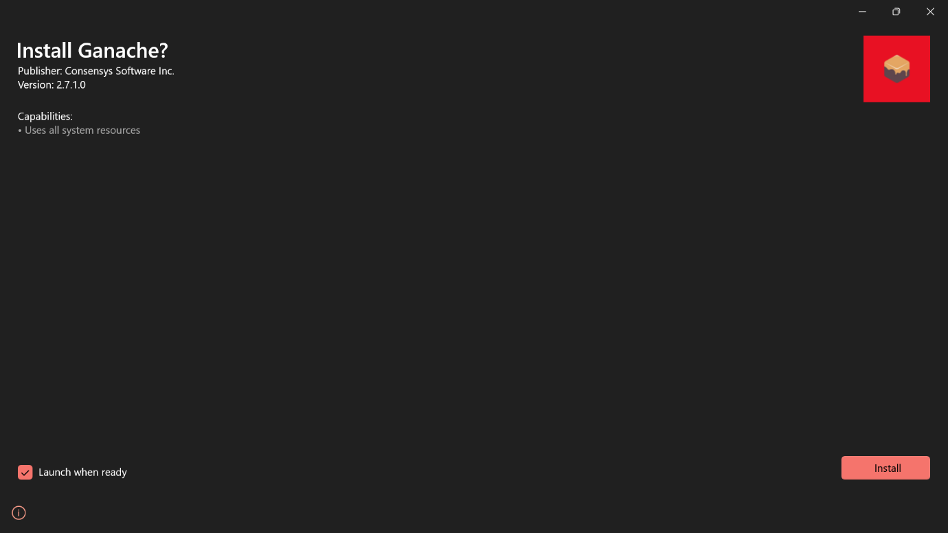

iii)De-select Analytics enabled and click on continue.

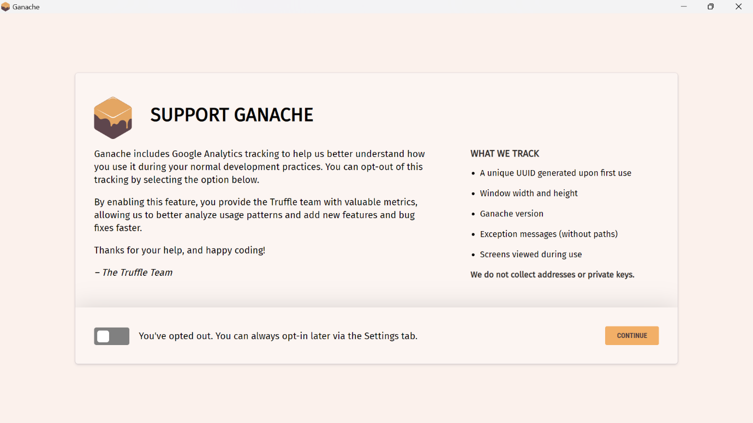

iv)Click on “Quicstart” for Ethereum.

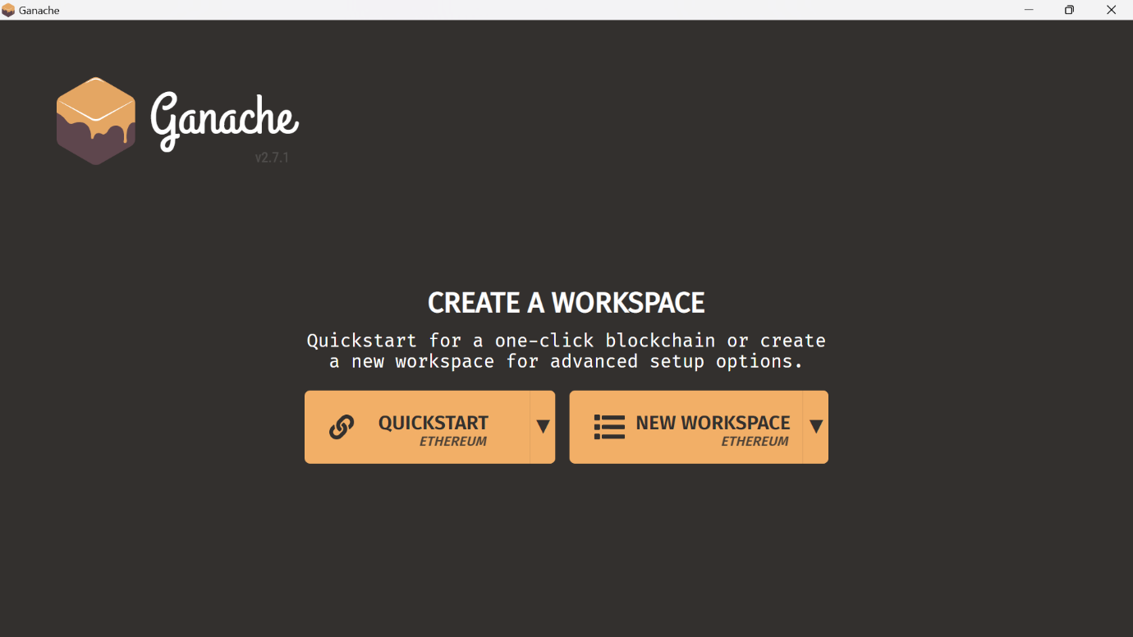

v)Now, to deploy the smart contract, go to your “Remix IDE” and change environment to “Dev Ganache Provider”. Change the endpoint to 7545 and select “Ok”.

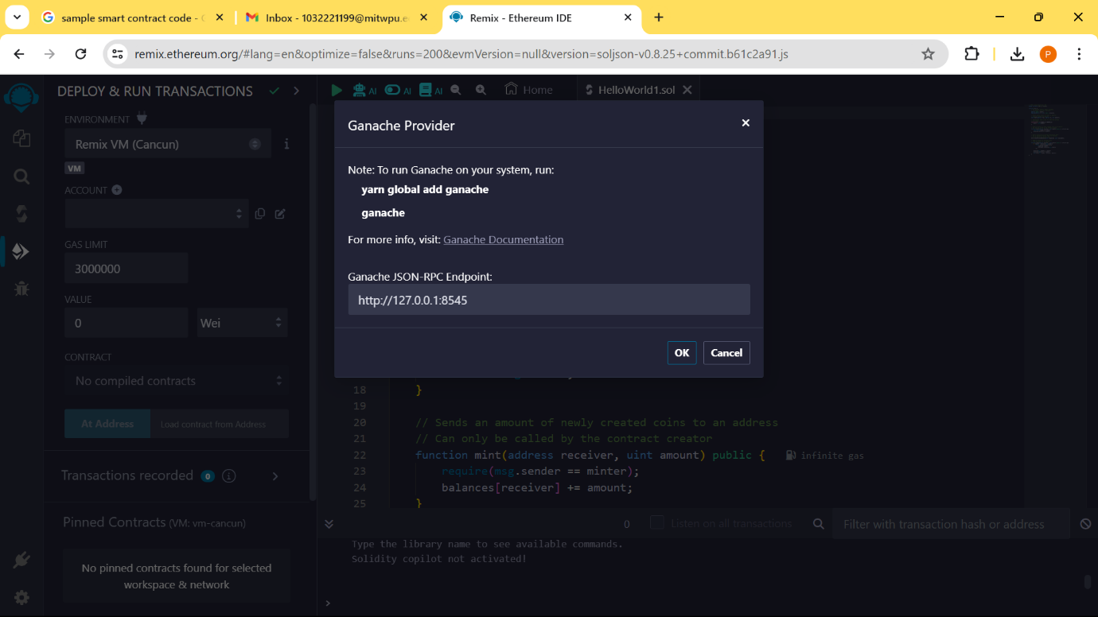

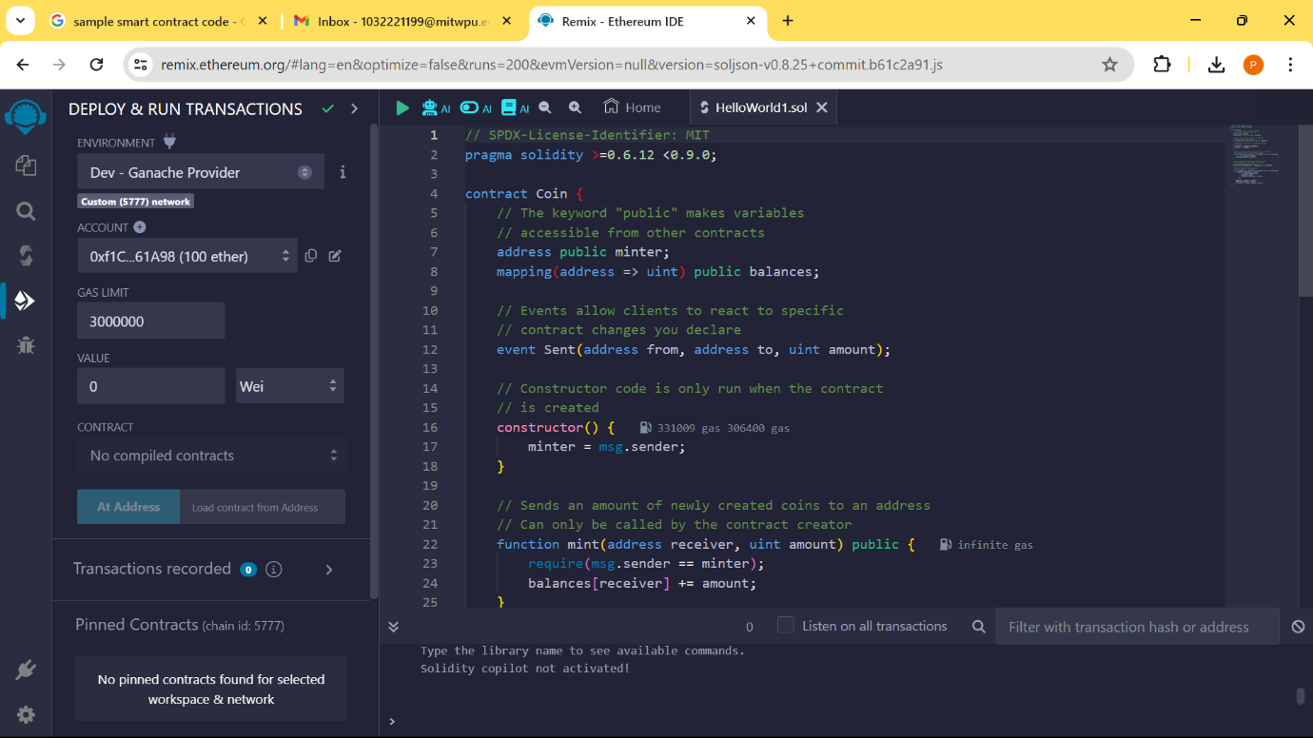

vi)Deploy the contract and Forcefully “Send Transaction”.

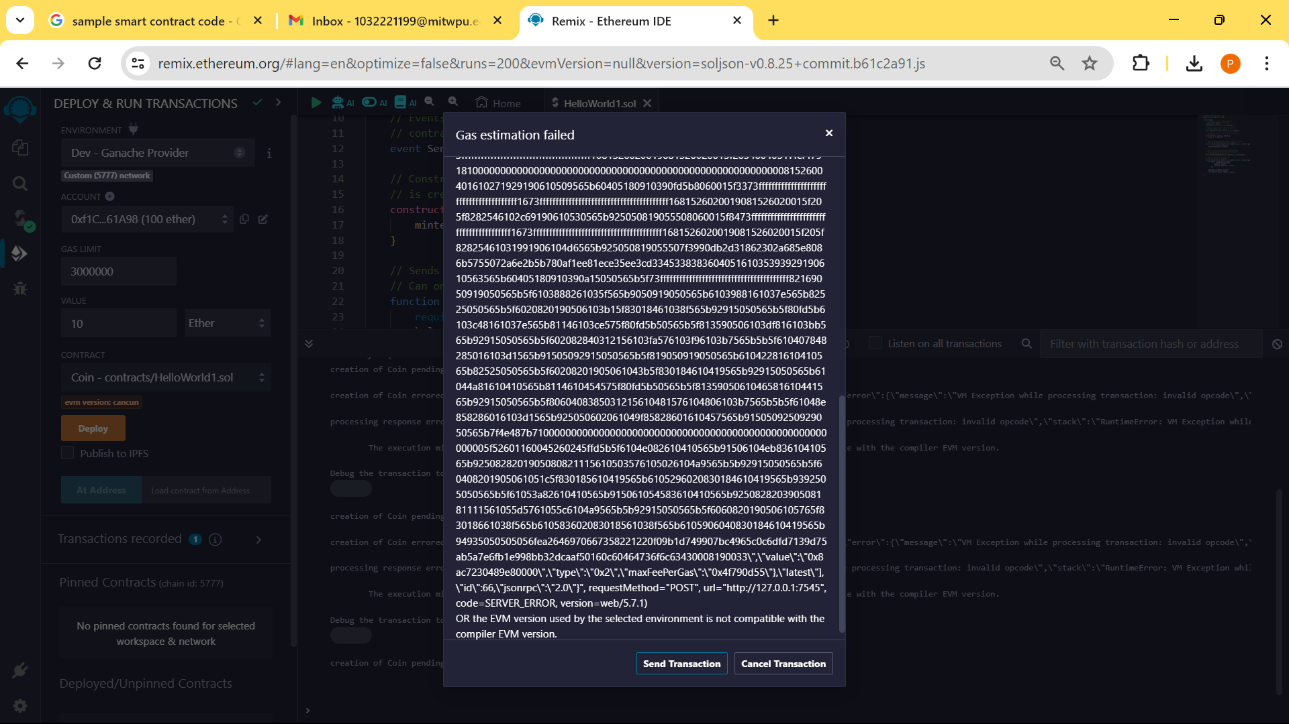

vii)Finally, Verify the Transaction in Ganache Application under “Transactions” tab.

